**Subscriptions and RBAC – Entra**

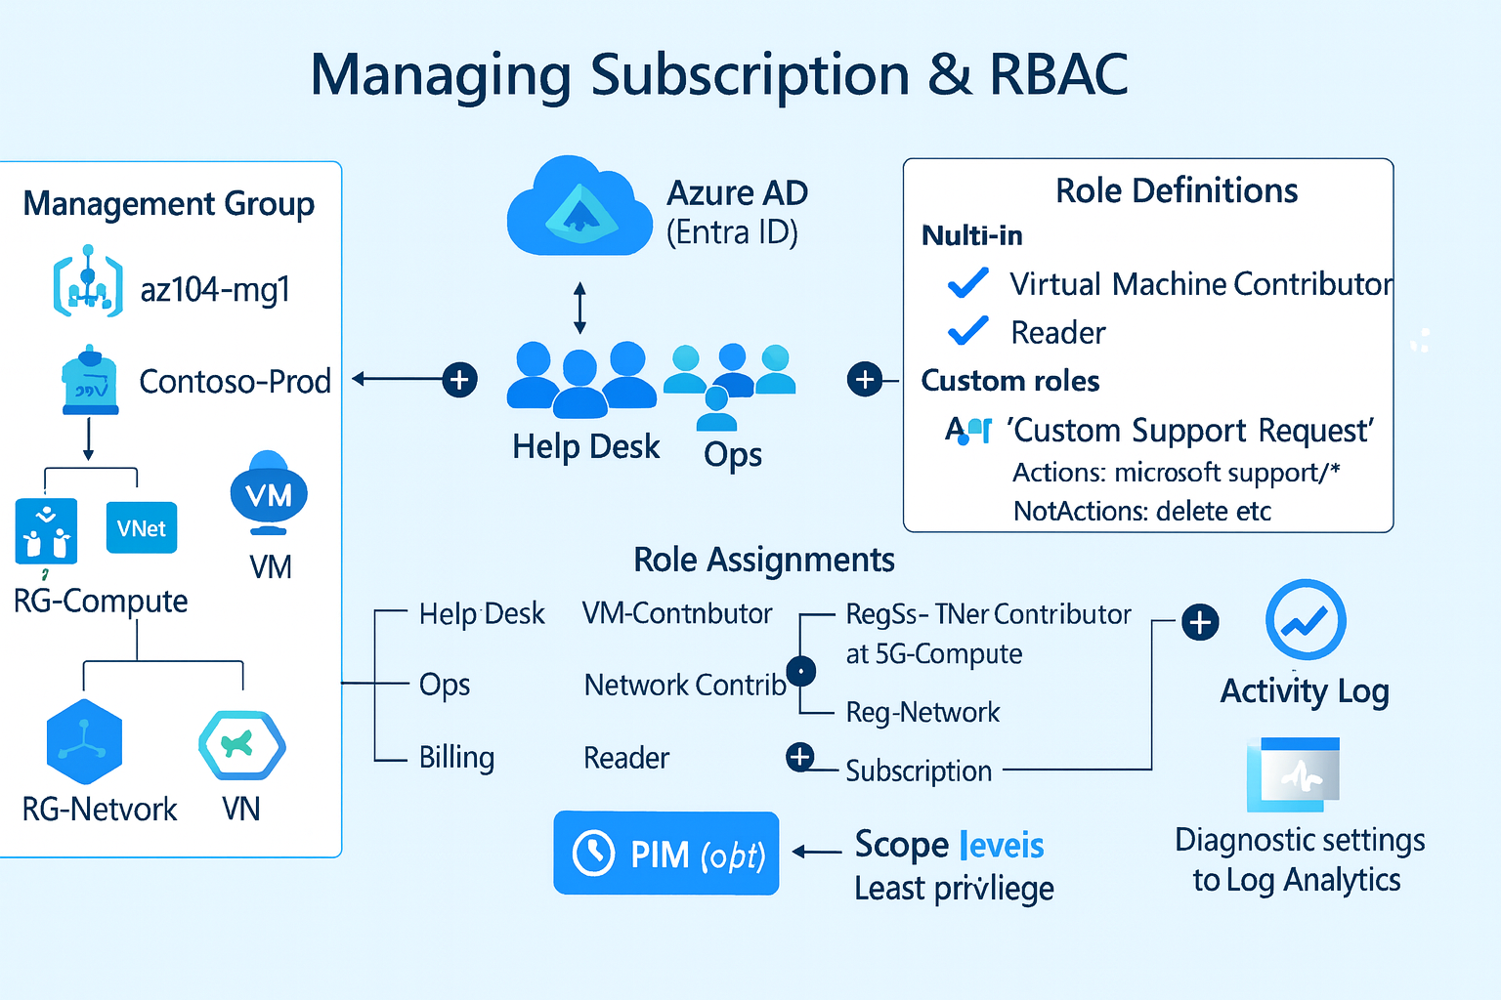

Microsoft Entra ID – Manage – Properties

Refresh



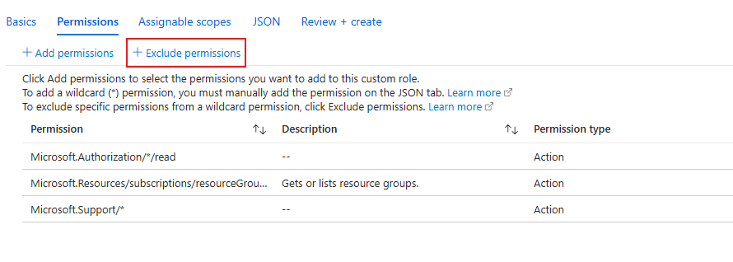

Ensure Management Groups appears under Assignable Scopes

Monitor assignments with Activity logs

